Robert Newcomm
It is with great sorrow that I announce the passing of Robert Newcomm last Thursday, September 28th at the age of 93. Robert was a member of the Lakewood Fire Department with 27 years of service from 1953 through 1980 retiring at the rank of Assistant Chief.

The family has indicated that they are not planning any memorial services or viewing at this time, however, Robert was a member of the Army and is expected to be interred at Fort Logan. The family has indicated that this may be several weeks to months down the road. I will provide additional information as I receive it.

Howard Betts
Howard Betts passed away last Friday at the age of 101. He retired from the Lakewood Fire Department as an Assistant Chief in the 70s. He will be laid to rest on Wednesday June 28th. The memorial service will be at 11AM at Olinger Mortuary, Crown Hill Cemetery in Wheat Ridge - 7777 W 29th. Visitation will be Tuesday 6PM – 8PM. His obituary will be in the Denver Post on Monday or at the Olinger website.
Ed Bailey
Survived by: Annie Jo Bailey (Wife)
24093 Mooresville Road
Athens, AL 35619
Ed retired 1/2/1978
Bill Molnar
Memorial service at: Applewood Baptist Church
Location: 11200 W. 32nd Wheat Ridge, CO 80033
Services schedule: Wednesday, August 24th at 10:00am
It is with great sorrow that I announce the passing of Bill Molnar at the age of 82. Bill was a member of the Lakewood Fire Department with 20 years of service from 1967 through 1987 retiring at the rank of Engineer.
Don Coxen
Visitation: Monday, August 8, 2016 from 10:00 AM to 11:00 AM
Service: Monday, August 8, 2016 at 11:00 AM
Interment: Fort Logan National Cemetery Area B 12:30 PM
Don Coxen passed away July 27th, 2016 he was 84. Don retired from Lakewood Fire Dept. as an Engineer in 1986 after 20 years of service.( His brother Bill, also a retired Lakewood fireman) A Marine, served during the Korean War.
He was born February 3, 1932 in Osage City, Kansas, the son of Calvin and Thelma (Verna) Coxen. On October 16, 1954 he married Betty J. Strunk in Denver, CO. He honorably serviced as a Marine in the Korean War. He was an Engineer for the Lakewood Fire Department for 20 years, retiring in 1986.
He is survived by Daughter, Vicki S. Tilden; Three Grandchildren, Christopher D. Pierce, Stacie L. Pierce, Dawnelle R. Tilden; Two Great-Grandchildren, Darian N. Johnson, Leon Johnson; Brother, Bill E. (Carol) Coxen. He is preceded in death by his Parents, Wife, Betty J. Coxen, Sister, Marianna Riggs

Dennis Lucas
It is with great sorrow that I announce the passing of Dennis Lucas at the age of 69. Dennis was a veteran of Lakewood and West Metro Fire retiring as an Engineer in 1999 with nearly 25 years of service.
Dennis retired out of town, last living in Mesa Arizona. As of this time, I have no information on any pending memorial services for Dennis. I will post any updates as I receive them.
Ruth Svoboda
Former Volunteer
Memorial, Tues., May 17, 2pm, Presbyterian Church, 8210 W. 10th Ave., Lakewood
Jean Murr (1951 – 2016)
Interment Information: Tuesday May 10th, 2016 Time: 10:30am – 11am
Fort Logan National Cemetery (http://www.cem.va.gov/cems/nchp/ftlogan.asp)
4400 W. Kenyon Ave, Denver, CO 80236
Reception Information: Tuesday May 10th, 2016
Time: 12pm
The Retreat at Solterra
(http://solterra-community.com/the-retreat)
15250 West Evans Ave
Lakewood, CO 80228
In Lieu of Flowers: Per Cathy Davis-
“I received this information from Jer a few days ago and meant to include it with the Service information, but forgot. I had asked him about donations as opposed to flowers and this was his response. “I want to encourage you to check out www.newcomerdenver.com
There you can view Jean's Obituary. What they have done looks really nice. If you click on the link below it will take you to UCH's foundation website. They took down the Tee'd off at cancer page and turned it in to Jean's page.” http://uch.thankyou4caring.org/JeanMurr_TOAC

Map of Fort Logan Cemetery
Duncan Scott
It is with great sorrow that we announce Duncan Scott lost his yearlong battle with Hodgkin’s Lymphoma. Duncan passed away this Friday at the age of 57. He was a member of Lakewood Fire and West Metro Fire Rescue with 20 years of service (July 1, 1984 – July 9, 2004). He retired at the rank of Engineer.
He is survived by his wife Christy, his daughter Maggie, his son Derek and his granddaughter, McKinley. The family will be holding a memorial service this Saturday, April 2, 2016 at 14:00- at the Shepherd of the Hills Church located at 11500 W. 20th Ave, Lakewood, CO.
The family has asked for fire department honors at the memorial service.
Warren Edward Teasdale
(June 15th, 1935 – October 7, 2015)
Funeral Service: Thursday Oct. 15, 2015
Time: 6:30pm
Atonement Lutheran Church
6281 West Yale Ave.
Lakewood, CO 80227
303-985-1122
Warren Edward Teasdale, 80, of Lakewood, Colorado, passed away October 7, 2015. He was born in Oceanside, New York on June 15, 1935. Warren graduated from Free Port High School and received a Bachelor’s of Science in Geology from Hofstra University. He was married to Dee F. Cornell April 22, 1961. Warren had a career in Hydrology/Geology for the U.S. Geological Survey, Water Resources Division. He was a member of Kiwanis Golden K, West Metro Fire Department Outreach, ASTM, and SPEBSQSA and had a passion for singing, camping, as well as spending time with family. He was survived by his wife Dee F. Teasdale, his children Deborah (Wilbur) Holz, and Scott Teasdale. His grandchildren Sarah, Rebekah and Anna Holz of Rapid City, South Dakota.

Tom Dellinger
(Retired Lakewood Firefighter 1957 – 1983)
Tom retired as an Assistant Chief and passed away while living in Arizona on May 31, 2015.

Angela Hester
Daughter of Civil Service Member Ed Hester
Expressions of Sympathy can be sent to:
Ed and Diana Hester
10698 W. Vista Dr.
Littleton, CO 80127
Memorial Mass: Monday October 26, 2015
Time: 10:30am
St. Frances Cabrini Church
11892 E. Hilltop Rd.
Parker, CO 80134
*In Lieu of flowers, memorial donations are requested to Praying Hands Ranch

Robert Marlin
(April 29, 1952 – August 1, 2015)
EMS Coordinator for West Metro Fire- March 19, 1997 – December 31, 2011)
Memorial Service: Thursday August 6, 2015
Time: 10am
Fiddlers Green Amphitheater
6350 Greenwood Plaza Blvd.
Englewood, CO
It is with great sadness that I announce that paramedic Bob Marlin passed away at 0200 on August 1, 2015 at St. Anthony Hospital. Bob was surrounded by friends and family during his final moments and went peacefully. Bob was an icon in EMS in Colorado. He began his career in the early 1970’s and was a student in cycle 1 of the St. Anthony Paramedic program. Following this training, he went on to work at Denver General in the Paramedic Division, where he eventually became the Chief Paramedic. Following his time there, he worked for St. Anthony Hospital as an EMS Educator, West Metro Fire Rescue in an EMS Educator/QI role, and most recently South Metro Fire Rescue in an Educator/QI role. In addition to his full time jobs, bob remained an active part-time instructor with St. Anthony PreHosptial Services until the time of his passing. Throughout Bob’s educational tenure, he remained active as a field paramedic with various agencies, including Gilpin County Search and Rescue and Clear Creek Ambulance.
Please keep Bob’s family in your prayers during this time.
Questions/ Comments contact: Scott Phillips Ext. 534166
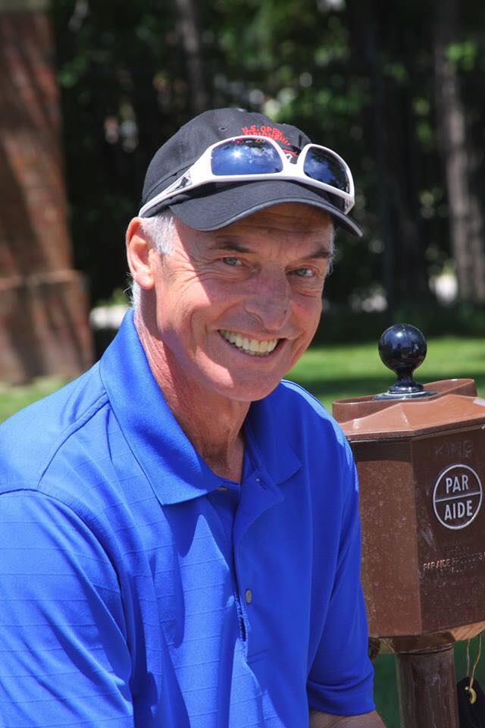

Clarence C. Millsapps
(December 14, 1930 – June 14, 2015)
Obituary
It is with deep sorrow that I announce the passing of Engineer/Master Mechanic, Clarence Millsapps at the age of 84. Clarence was a member of the Bancroft Fire Protection District for 20 years from 1964 through 1984. I have spoken with his wife, Frieda. She indicated that they will not be having any memorial services until perhaps same time in August. 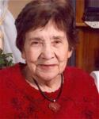
Margaret Medina Rael
(February 5, 1938 – June 3, 2015)
Retired Bancroft Fire Captain Albert Rael’s wife passed away on Wednesday June 3, 2015.
Margaret is survived by husband, Albert; children, Sharon Gonzales, Alberta Rael, Diana Rael, Kathy DiFranco, Michael Rael; numerous grandchildren and great grandchildren; 1 sister and 2 brothers. Preceded in death by 5 brothers and 5 sisters.
All at: Archdiocese of Denver Mortuary
Visitation: Wednesday June 10, 2015
Time: 8am – 9am
Rosary: Wednesday June 10, 2015
Time: 9am
Interment, Mount Olivet Cemetery

